InterSystems Health Connect (HC) / Outpatient Pharmacy Automation Interface (OPAI) 1.0

PSO*7*522

Deployment, Installation, Back-Out, and Rollback Guide



March 2019

Department of Veterans Affairs (VA)

Office of Information and Technology (OIT)

Revision History

| Date | Revision | Description | Author |
| --- | --- | --- | --- |
| 03/06/2019 | 1.0 | Final DIBRG Release Document. | VA Tech Writer: TB |
| 02/27/2019 | 0.12 | Updated TBD dates for IOC/National release on pg 6 and 9, updated date in footer and cover page. | Halfaker |
| 12/18/2018 | 0.11 | Updated sections at 5 and 6. | Halfaker |
| 12/10/2018 | 0.10 | Tech Edit Review and Updates:   * Accepted all changes to date. * Missing dates in Section 3.3.4. | VA Tech Writer: TB |
| 11/27/2018 | 0.9 | Tech Edit Review and Updates:   * Reviewed prior edited sections by contractor, since last VA tech writer review. Accepted all changes and removed flagging comments with exceptions shown in next bullet. * Updated Sections: 3.2 (see reviewer comment/question), 3.2.1, 4.1.1, 4.1.1.1 (new Header); Figure 5 (see reviewer comment/question), 5.2.2, 5.3, and 5.4. | VA Tech Writer: TB |
| 09/12/2018 | 0.8 | Updated the following sections: 3.2, 3.2.1, 3.2.3, 4.2, 5.2.1, 5.2.2, and 6.1. | Halfaker: SM |
| 09/05/2018 | 0.7 | Added Section 4.1.1, “Pre-Install VistA Check.” | Halfaker: TJ |
| 08/09/2018 | 0.6 | Halfaker Review of Reviewer Edits:   * Corrected acronym to reflect "Health Connect” in Section 1.1. * Removed diagram in system architecture in Section 3, Figure 1. * Provided elaboration on Section 4.3, Figure 8. * Provided elaboration on Appendix A Section 7.1.2, item 6. * Provided elaboration on Appendix B Section 7.2, item 1e. * Updated Appendix B Section 7.2, item 2a to reflect OPAI. * Updated Appendix B Section 7.2, item 3a to reflect OPAI. * Updated Appendix B Section 7.2, item 5d to reflect “e.g.” | Halfaker PM: LM |
| 07/24/2018 | 0.5 | VA Tech Edit Review:   * Accepted all vendor documentation changes to date. * 1: Updated content based on contractor review/edits. * 2: Updated Table 1 for “FM24” project entry. * 3: Added “OPAI” throughout to clarify when content was specific to OPAI messages.  Also, replaced “Palo Alto, CA” site with “Oklahoma City, OK.” * 3.2.2: Listed current IOC sites. * 3.2.3: Updated Table 2. * 3.3: Updated resource bullet list. * 3.3.1: Facility Specifics, updated text. * 3.3.2: Hardware, updated text. * 3.3.4: Updated date bullets; pending final dates. * 4.3: Reformatted procedural steps. * Added boldface to patch IDs, file names, etc. throughout.   Minor formatting updates throughout. | VA Tech Writer: TB |
| 06/11/2018 | 0.4 | VA Tech Edit Review. Accepted all vendor documentation changes to date:   * Updated Figure 7, Figure 8, and Figure 10. * Corrected “Rollout Procedure” V1 and P1 steps in Section 3. * Added site information to Table 2. * Updated XML file reference in Section 3.3.3. * Updated Section 4.6. * Corrected sample operation names in Section 7.2,, Step 2a and Step 4d. | VA Tech Writer: TB |
| 06/06/2018 | 0.3 | Halfaker Review of Tech Edits:   * Architect (DE) and developer(GS) addressed as many items as possible at this time. * Updated revision and sent back for VA TW review. | Halfaker CM: MT |
| 05/17/2018 | 0.2 | VA Tech Edit Review:   * Reformatted document to follow current OIT documentation standards and style guidelines. * Removed intranet links (inside the VA firewall), since this document will be located on the internet (outside the VA firewall). * Reviewed and edited document for Section 508 conformance (e.g., added alternate text to all images). | VA Tech Writer: TB |
| 05/07/2018 | 0.1 | Initial document based on the Veteran-focused Integration Process (VIP) Deployment, Installation, Back-Out, and Rollback Guide template Version 2.2, released on March 2016. | Halfaker: DE |

Table of Contents

Revision History ii

List of Figures vi

List of Tables vii

1 Introduction 1

1.1 Purpose 1

1.2 Dependencies 1

1.3 Constraints 1

2 Roles and Responsibilities 2

3 Deployment 3

3.1 Timeline 6

3.2 Site Readiness Assessment 6

3.2.1 Deployment Topology (Targeted Architecture) 7

3.2.2 Site Information (Locations, Deployment Recipients) 7

3.2.3 Site Preparation 8

3.3 Resources 8

3.3.1 Facility Specifics 9

3.3.2 Hardware 9

3.3.3 Software 9

3.3.4 Communications 9

3.3.4.1 Deployment/Installation/Back-Out Checklist 9

4 Installation 10

4.1 Pre-installation and System Requirements 10

4.1.1 Pre-Install VistA Check 10

4.1.1.1 Narrative Validation 10

4.2 Platform Installation and Preparation 12

4.3 Download and Extract Files 12

4.4 Database Creation 14

4.5 Installation Scripts 14

4.6 Cron Scripts 14

4.7 Access Requirements and Skills Needed for the Installation 15

4.8 Installation Procedure 15

4.9 Installation Verification Procedure 15

4.10 System Configuration 15

4.11 Database Tuning 15

5 Back-Out Procedure 16

5.1 Back-Out Strategy 16

5.2 Back-Out Considerations 16

5.2.1 Load Testing 16

5.2.2 User Acceptance Testing 16

5.3 Back-Out Criteria 16

5.4 Back-Out Risks 16

5.5 Authority for Back-Out 16

5.6 Back-Out Procedure 17

5.7 Back-Out Verification Procedure 17

6 Rollback Procedure 18

6.1 Rollback Considerations 18

6.2 Rollback Criteria 18

6.3 Rollback Risks 18

6.4 Authority for Rollback 18

6.5 Rollback Procedure 19

6.6 Rollback Verification Procedure 20

7 Appendices 21

7.1 Appendix A—Health Connect Production Namespace Configuration and Deployment 21

7.1.1 Creating a New Namespace 21

7.1.2 Deploying a Health Connect Production 21

7.2 Appendix B—Configuring a Health Connect Production 22

7.3 Appendix C—Starting and Stopping a Health Connect Production 24

7.3.1 Starting Health Connect Production 24

7.3.2 Stopping Health Connect Production 24

List of Figures

Figure 1: Current VIE Architecture for OPAI 3

Figure 2: IOC Rollout Breakdown for OPAI (Interim Architecture) 4

Figure 3: VIE, Health Connect, and OPAI Deployment Architecture and Rollout Procedure 5

Figure 4: OPAI Deployment Topology 7

Figure 5: Sample Narrative Validation—Narrative Non-Refillable RX parameter (NOTE: Some options have been skipped to save room for the example.) 11

Figure 6: Management Portal (MP)—Deployment Options 12

Figure 7: SM—Selecting Deployment File: OPAI 13

Figure 8: SM—Deploy Production Changes Screen: OPAI 14

Figure 9: Rollback Procedure from OPAI Messaging on Health Connect Back to VIE 19

Figure 10: InterSystems HealthShare—Production Configuration Screen: OPAI 23

List of Tables

Table 1: Roles and Responsibilities 2

Table 2: Site Preparation 8

Table 3: Deployment/Installation/Back-Out Checklist (Print Out When Needed) 9

# Introduction

This document describes the deployment, installation, back-out, and rollback instructions for the migration of Outpatient Pharmacy Automation Interface (OPAI) 1.0 from the Vitria Interface Engine (VIE) to InterSystems Health Connect (HC).

HC will replace VIE; currently in production, for the routing of OPAI messages.

This document includes information about:

* System support
* Issue tracking
* Escalation processes
* Roles and responsibilities involved in all activities

It provides clients, stakeholders, and support personnel with a smooth transition to Health Connect. It describes how to deploy and install the Health Connect in production as well as how to back out the product and roll back to a previous version or data set.

 **NOTE:** In cases where you are installing a *non*-developed commercial-off-the-shelf (COTS) product, you can use the vendor-provided user guide and installation guide. However, if those guides do *not* include a back-out recovery and rollback strategy, you must retain that information in this document.

## Purpose

The purpose of this guide is to provide a single, common document that describes how, when, where, and to whom the Health Connect (HC) will be deployed and installed; as well as how it is to be backed out and rolled back, if necessary. The guide also identifies resources, communications plan, and rollout schedule. Specific instructions for deployment, installation, back-out, and rollback are included in this document.

## Dependencies

VIE supports the routing of messages from several applications. Health Connect product will ultimately be replacing VIE. During the transition phase both products will be running concurrently.

## Constraints

HC is an approved product as per the VA’s Technical Reference Model (TRM). Defining the controls and constraints need to be determined.

# Roles and Responsibilities

Table 1: Roles and Responsibilities

| ID | Team | Phase / Role | Tasks | Project Phase (See Schedule) |
| --- | --- | --- | --- | --- |
|  | FM24 PMO | Deployment | Plan and schedule deployment (including orchestration with vendors). |  |
|  |  |  | Determine and document the roles and responsibilities of those involved in the deployment. |  |
|  | Operations and End-User | Deployment | Test for operational readiness. |  |
|  | Site and Operations | Deployment | Execute deployment. |  |
|  | Operations | Installation | Plan and schedule installation. |  |
|  |  |  | Ensure authority to operate and that certificate authority security documentation is in place. |  |
|  |  |  | Validate through facility POC to ensure that IT equipment has been accepted using asset inventory processes. |  |
|  | InterSystems | Installations | Coordinate training. |  |
|  | Development | Back-Out | Confirm availability of back-out instructions and back-out strategy (what are the criteria that trigger a back-out). |  |
|  | Operations/Development/ InterSystems | Post Deployment | Hardware, Software, and System Support. |  |

# Deployment

Figure 1 depicts the current VistA Interface Engine (VIE) architecture for OPAI:

Figure 1: Current VIE Architecture for OPAI



A parallel deployment of Health Connect (HC) is planned at a regional level. The VIE OPAI functionality will remain in place at each region. At Region 1, the OPAI Health Connect Production will run concurrently with VIE, replacing only the VIE OPAI functionality for the following Initial Operating Capabilities (IOC) sites:

* Tucson, AZ
* Oklahoma City, OK

VIE will stay online until the migration of all sites to Health Connect is complete. Should a failback be required, VIE will be online to serve that purpose.

VIE will continue to process messages for applications that have *not* yet been migrated. The Health Connect OPAI production will process OPAI messages.

This section provides the schedule and milestones for the deployment.

Figure 2 depicts the interim VIE and Health Connect architecture during the IOC rollout for OPAI:

Figure 2: IOC Rollout Breakdown for OPAI (Interim Architecture)



In summary, the IOC sites and Health Connect operations support will provide the port addresses for OPAI message traffic. As the VIE will be running on the old ports, Health Connect will use new ones. When an OPAI server transitions to the new ports, the message traffic is redirected through Health Connect. The informational patch **PSO*7*522** instructs the Veterans Health Information Systems and Technology Architecture (VistA) system administrators to change the logical link to redirect OPAI messages to the new Health Connect port and will no longer direct OPAI messages to VIE.

 **REF:** For details on how a OPAI production is deployed and configured, see Appendix A—Health Connect Production Namespace Configuration and Deployment.

On completion of the port configuration update for OPAI server and VistA logical link, the OPAI message traffic will be rerouted through the OPAI Health Connect production (see Figure 3):

Figure 3: VIE, Health Connect, and OPAI Deployment Architecture and Rollout Procedure



Rollout Procedure

This is a First-In-First-Out (FIFO) interface. This means that when rolling out OPAI from the VIE to the Health Connect interface, the outstanding OPAI VIE messages should be processed prior to starting the processing of messages through the Health Connect interface:

**V1** (Figure 3; Rollout Process: VistA System to Health Connect):

* Ensure the Health Connect OPAI operation(s) is switched off (**disabled**).
* Change the OPAI VistA logical link to point to the VistA listener on Health Connect.
* Verify that all OPAI messages are processed through VIE before OPAI messages are sent from Health Connect.
* Verify the OPAI messages are waiting to be processed through the Health Connect OPAI operation (**disabled**).
* Once verified, the Health Connect OPAI operation is switched on (**enabled**).

**P1** (Figure 3; Rollout Process: Health Connect to OPAI IOC Application Servers):

* Ensure the Health Connect VistA operation is switched off (**disabled**).
* Change the OPAI server to point to the OPAI listener on the Health Connect server.
* Verify that all OPAI messages are processed through VIE before OPAI messages are sent from Health Connect.
* Verify the OPAI messages are waiting to be processed through Health Connect VistA operation (**disabled**).
* Once verified, the Health Connect VistA operation is switched on (**enabled**).

## Timeline

Deployment timeline of **four** (**4**) hours has been allocated for IOC.

## Site Readiness Assessment

Regional Health Connect locations will need a site readiness assessment prior to deployment. OPAI servers will need to be pointed to those servers. Once sites are determined, site readiness assessments will need to be scheduled to prepare for deployment:

* IOC testing performed in mirror accounts:
* Tucson: completed on **06/21/2018**.
* Oklahoma City: completed on **08/10/2018**.
* Line of sight testing was scheduled and performed prior to deployment:
* Tucson: line of sight testing performed on **08/24/2018**.
* Oklahoma City: line of sight testing performed on **08/29/2018**.

### Deployment Topology (Targeted Architecture)

The OPAI deployment topology is depicted in Figure 4:

Figure 4: OPAI Deployment Topology

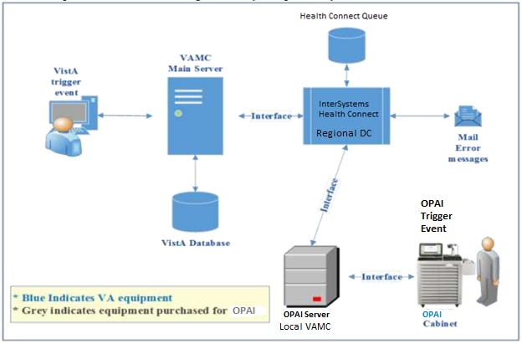

### Site Information (Locations, Deployment Recipients)

IOC sites:

* Tucson, AZ
* Oklahoma City, OK

### Site Preparation

Table 2 describes preparation required by the site prior to deployment.

Table 2: Site Preparation

| Site/Other | Problem / Change Needed | Features to Adapt/Modify to New Product | Actions/Steps | Owner |
| --- | --- | --- | --- | --- |
| **Tucson, AZ** | Establish IP communication | Not Applicable (N/A) | Ensure listener is enabled and ACL allows HealthShare servers IP range to connect | Local IT Admin or Dispenser Admin |
|  | Standard acknowledgment (ACK) for RDS_O13 transmitted from ScriptPro server | Vendor provides patch to be installed on ScriptPro server | Vendor installs patch on ScriptPro server | Vendor |
| **Oklahoma City, OK** | Establish IP communication | N/A | Ensure listener is enabled and ACL allows HealthShare servers IP range to connect | Local IT Admin or Dispenser Admin |
|  | Innovation devices need transmit standard RRD_O14 response | Vendor provides patch to be installed on Innovation server | Vendor installs patch on Innovation server | Vendor |

## Resources

The following support resources will be available with OPAI:

* Pharmacy Personnel
* Pharmacy Automation Data Processing Application Coordinator (ADPAC)
* Health Connect Support Operations Team
* VistA HL7 Support, VistA Patch Installer
* OPAI Equipment Vendor Support

### Facility Specifics

This section does *not* apply to HL7 Health Connect and OPAI. Virtual meetings can be used to assist sites; similar to what was used for IOC testing sessions.

### Hardware

There are no special hardware requirements for sites using HL7 Health Connect and OPAI.

 **REF:** For details about who is responsible for preparing the site to meet these hardware specifications, see Table 1: Roles and Responsibilities.

### Software

The OPAI software deployment is made up of the following:

* OPAI Health Connect Production Extensible Mark-up Language (XML) file (e.g., **Export-HCM_Production_HL7RouterProduction_OPAIv1.xml**)—The Health Connect XML file will be delivered from the Community Resource and Referral Center (CRRC) development/test environment.
* Informational **PSO*7*522** is available on FORUM.

 **REF:** For details about who is responsible for preparing the site to meet these software specifications, see Table 1: Roles and Responsibilities.

### Communications

Communications and notification activities include:

* Kick Off meetings:
* IOC Kick Off: **06/12/2018**
* National Release Kick Off Planned for: **3/25/2019**
* Cutover to IOC Production Tucson, AZ: **03/05/2019**
* Cutover to IOC Production Oklahoma City, OK: **09/06/2018**

#### Deployment/Installation/Back-Out Checklist

For rollback procedures, see Section 6, “Rollback Procedure.”

Table 3: Deployment/Installation/Back-Out Checklist (Print Out When Needed)

| Activity | Day | Time | Individual Who Completed Task |
| --- | --- | --- | --- |
| Deploy |  |  |  |
| Install |  |  |  |
| Back-Out |  |  |  |

# Installation

## Pre-installation and System Requirements

The **HCM** namespace for the Health Connect production needs to be created for every deployment of Health Connect.

### Pre-Install VistA Check

The following word-processing fields of the OUTPATIENT SITE (#59) file may contain “blank lines” with control characters that may cause incorrect HL7 message termination during processing:

* NARRATIVE FOR COPAY DOCUMENT (#59.01004) field
* NARRATIVE REFILLABLE RX (#59.01005) field
* NARRATIVE NON-REFILLABLE RX (#59.01006) field

To correct this by removing blank lines from these fields, follow the steps in the “Narrative Validation” section. (Also, see the “Performing the Implementation” section in the *Outpatient Pharmacy Automation Interface Installation Guide*.)

#### Narrative Validation

To remove blank lines from fields, do the following:

1. Check the following fields in the OUTPATIENT SITE (#59) file:

NARRATIVE FOR COPAY DOCUMENT (#59.01004)

NARRATIVE REFILLABLE RX (#59.01005)

NARRATIVE NON-REFILLABLE RX (#59.01006)

These are word-processing fields, containing information from the site regarding the procedures for the patient to follow; information may include telephone numbers, mailing addresses, etc. Information in these parameters may incorporate "blank lines" with control characters that may cause incorrect HL7 message termination during processing.

1. Edit the fields in Step 1 as necessary to remove "blank lines" with control characters.
2. Save changes to the edited fields.

Figure 5: Sample Narrative Validation—Narrative Non-Refillable RX parameter  
(NOTE: Some options have been skipped to save room for the example.)

NARRATIVE REFILLABLE RX

NARRATIVE REFILLABLE RX:. . .

. . .

machinery.\.sp\May cause dizziness\.sp\May cause blurred vision\.sp\Call

your doctor immediately if you have mental/mood changes like confusion,

new/worsening feelings of sadness/fear, thoughts of suicide, or unusual

behavior.\.sp\Do not take aluminum or magnesium antacids within 2 hours

of taking this medication.\.sp\It is very important that you take or use

this exactly as directed. Do not skip doses or discontinue unless

directed by your doctor.\.sp\Read the Medication Guide that comes with

this medicine|Drug Warning Narrativevisit

<http://www.va.gov/healthbenefits/cost/copay_rates.asp>.

Edit? NO// **YES**

==[ WRAP ]==[INSERT ]========< NARRATIVE REFILLABLE R[Press <PF1>H for help]====

May cause drowsiness. Alcohol and marijuana may intensify this effect.

Use care when operating a vehicle, vessel (e.g., boat), or

machinery.\.sp\May cause dizziness\.sp\May cause blurred vision\.sp\Call

your doctor immediately if you have mental/mood changes like confusion,

new/worsening feelings of sadness/fear, thoughts of suicide, or unusual

behavior.\.sp\Do not take aluminum or magnesium antacids within 2 hours

of taking this medication.\.sp\It is very important that you take or use

this exactly as directed. Do not skip doses or discontinue unless

directed by your doctor.\.sp\Read the Medication Guide that comes with

this medicine|Drug Warning Narrativevisit

http://www.va.gov/healthbenefits/cost/copay_rates.asp.

[eof]

<=======T=======T=======T=======T=======T=======T=======T=======T=======T>======

NARRATIVE REFILLABLE RX modified:

==[ WRAP ]==[INSERT ]========< NARRATIVE REFILLABLE R[Press <PF1>H for help]====

May cause drowsiness. Alcohol and marijuana may intensify this effect.

Use care when operating a vehicle, vessel (e.g., boat), or

machinery.\.sp\May cause dizziness\.sp\May cause blurred vision\.sp\Call

your doctor immediately if you have mental/mood changes like confusion,

new/worsening feelings of sadness/fear, thoughts of suicide, or unusual

behavior.\.sp\Do not take aluminum or magnesium antacids within 2 hours

of taking this medication.\.sp\It is very important that you take or use

this exactly as directed. Do not skip doses or discontinue unless

directed by your doctor.\.sp\Read the Medication Guide that comes with

this medicine|Drug Warning Narrativevisit

http://www.va.gov/healthbenefits/cost/copay_rates.asp.

[eof]

Do you want to save changes? **YES**

<=======T=======T=======T=======T=======T=======T=======T=======T=======T>======

Saving text ....

 **REF:** For deployment steps, see Appendix A—Health Connect Production Namespace Configuration and Deployment.

## Platform Installation and Preparation

Platform installation and preparation steps are outlined in the sections that follow.

## Download and Extract Files

The deployment of the OPAI production is achieved by extracting a Health Connect deployment file (**HCM_Production_HL7RouterProduction-Deploy1.1.xml**) through the Health Connect Menu.

To download and extract the files, do the following:

1. Access the **Deploy** option:

**Management Portal (MP) 🡪 Ensemble 🡪 Manage 🡪 Deployment Changes 🡪 Deploy**

Figure 6: Management Portal (MP)—Deployment Options

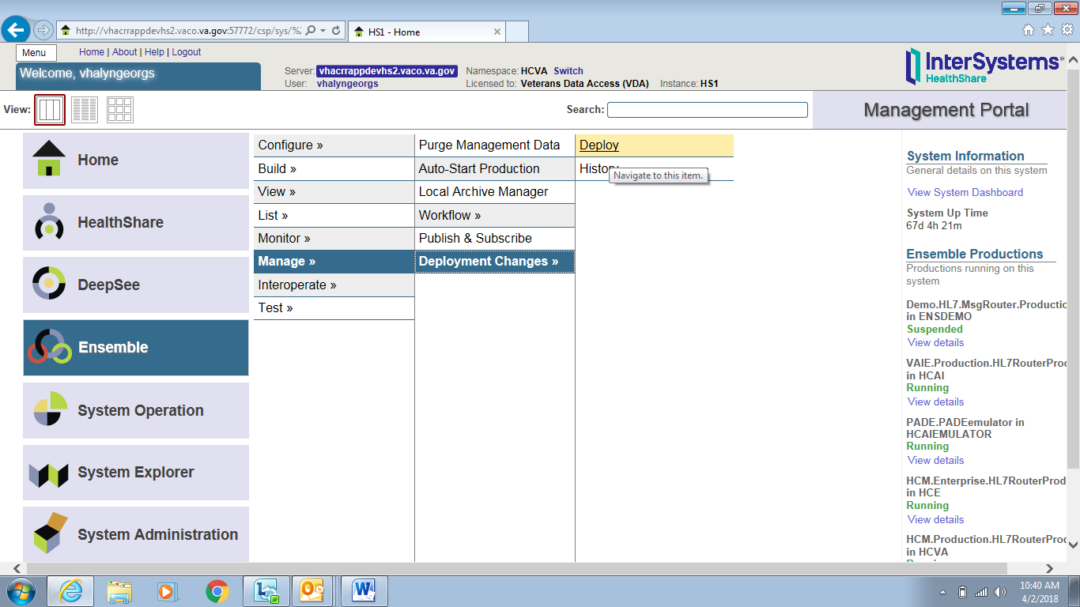

1. Select the OPAI deployment file (e.g., **Export-HCM_Production_HL7RouterProduction-20180605104008_OPAIv1.xml**):

**Open Deployment 🡪 Select Deployment file 🡪 Ok**

Figure 7: SM—Selecting Deployment File: OPAI

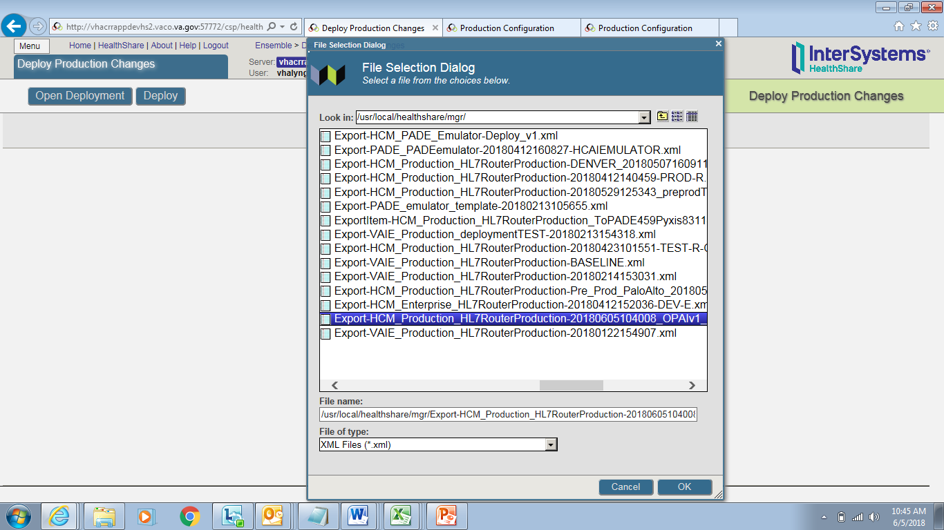

1. When you select **Deploy** (Figure 7), the Deploy Production Changes screen is displayed, as shown in Figure 8:

Figure 8: SM—Deploy Production Changes Screen: OPAI

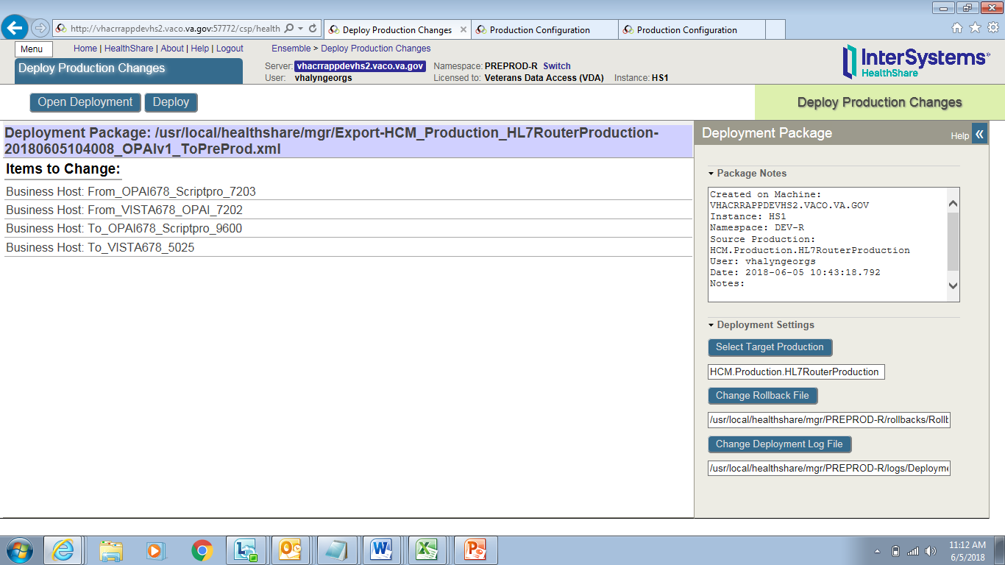

 **REF:** For deployment steps, see Appendix A.

## Database Creation

Database created by infrastructure team as part of IOC deployment. The Health Connect HL7 Messaging Production Operations Manual (POM; **HC-HL7_Messaging_1_0_POM.pdf**) provides database details.

 **REF:** The **HC-HL7_Messaging_1_0_POM.pdf** document is stored on the EHRM FM24 Documentation Jazz RTC repository.

## Installation Scripts

There are no installation scripts for this installation.

 **REF:** For deployment steps, see Appendix A.

## Cron Scripts

Cron Scripts do *not* apply to the Health Connect/OPAI deployment.

## Access Requirements and Skills Needed for the Installation

Users require **Administration** privileges to create a database for every installation of InterSystems Health Connect (HealthShare). Subsequent deployments should *not* require this level of access, as the latest Health Connect production deployment will be done through the Health Connect menu.

 **REF:** For deployment steps, see Appendix A.

## Installation Procedure

For deployment steps, see Appendix A.

## Installation Verification Procedure

For installation and verification procedure, see Step 10 under the deployment procedure in Appendix A.

## System Configuration

To start the OPAI Health Connect production, follow the steps in Appendix C.

Once the production is running, the OPAI production business services, operations, and routers should be enabled (See Appendix B).

## Database Tuning

Currently, no database tuning is expected or required for OPAI on HL7 Health Connect.

# Back-Out Procedure

## Back-Out Strategy

Since this is a first time install, the only back-out option is to un-deploy Health Connect (HC) and repoint OPAI to VistA Interface Engine (VIE) last known software configuration and platform settings.

The back-out process will repoint OPAI servers and the VistA logical links back to the VIE instance. This process will identify unsent OPAI messages on Health Connect and resend to OPAI/VistA.

The configuration and operational support will be in place as the VIE platform will still be in production, providing message routing for other applications. Coordination with each site and the operations teams (if VIE and Health Connect use different resources) for server configuration and VistA logical link update will be key to a successful back-out.

## Back-Out Considerations

VIE (for remaining supported applications) and Health Connect (for migrated OPAI and other sites) will be running in parallel (see Figure 3).

The repointing of OPAI servers and VistA systems would need to be coordinated with site point of contact (POC), VIE, and Health Connect operations.

### Load Testing

Not applicable (N/A).

### User Acceptance Testing

User acceptance testing was performed in IOC mirror testing. Execution results are attached in Section 3.2, “Site Readiness Assessment.”

## Back-Out Criteria

Back-Out criteria will be any impact to patient care.

## Back-Out Risks

Back-Out risks are to the schedule of the Health Connect (HC) / VistA Interface Engine (VIE) migration project.

## Authority for Back-Out

Authority for back-out will be determined by the following:

* Ken Leonard (FM24 Project Manager)
* Annette Parsons (HC Operations Project Manager)

## Back-Out Procedure

Back-out procedures are determined to be the same for this initial deployment of OPAI on HL7 Health Connect.

## Back-Out Verification Procedure

The following group will determine if messages are passing on VIE server if back out required:

VIE National Admins ([VIENationalAdmins@va.gov](mailto:VIENationalAdmins@va.gov))

# Rollback Procedure

## Rollback Considerations

The rollback option is to un-deploy Health Connect (HC) and repoint the OPAI devices to the VistA Interface Engine (VIE) last known software configuration and platform settings.

Secondly, the VistA logical links need to point back to the VIE instance. This process will identify unsent OPAI messages on Health Connect and resend to OPAI/VistA (see Figure 9 for rollback procedure).

The repointing of OPAI servers and VistA systems would need to be coordinated with the site point of contact (POC), VIE, and Health Connect operations, the site's outpatient pharmacy department, OPAI vendor(s) and OIT HL7 Support Analyst.

Migration to Health Connect is occurring during off-hours when no prescription dispense requests will be transmitted. Test messages will be sent to confirm successful migration to Health Connect and would *not* be needed to be resent in case a rollback is required. Any production messages (*not* test messages) that might be submitted during migration and would require resubmission and would need to be coordinated with the site point of contact, VIE operations, and Health Connect operations.

## Rollback Criteria

Rollback criteria will be any impact to patient care.

## Rollback Risks

Rollback risks are to the schedule for the Health Connect (HC)/VistA Interface Engine (VIE) migration project.

## Authority for Rollback

Authority for rollback will be determined by the following:

* Ken Leonard (FM24 Project Manager)
* Annette Parsons (HC Operations Project Manager)

## Rollback Procedure

This is a First-In-First-Out (FIFO) interface, which means that when rolling back from the Health Connect (HC) interface, the Health Connect messages should be processed prior to processing messages through the VistA Interface Engine (VIE) interface.

Figure 9 depicts the rollback procedure from OPAI messaging on Health Connect back to VIE:

Figure 9: Rollback Procedure from OPAI Messaging on Health Connect Back to VIE



**V2** (Figure 9; Rollback Process: VistA System to VIE):

* Ensure the Health Connect VistA listener is switched off (**disabled**).
* Verify that all OPAI messages are processed through Health Connect to OPAI before OPAI messages are sent from VIE.

Once verified, the OPAI logical link in VistA is pointed to VIE. Here are the steps involved for repointing the VistA logical link IP address and port back to the VIE IP address and port:

* Stop the PSO DISP Logical Link with HL7 Menu option: Start/Stop Links
* Edit the PSO DISP Logical Link with HL7 menu option: Link Edit.
* Edit the HL LOGICAL LINK for PSO DISP and replace the existing TCP/IP ADDRESS and existing TCP/IP PORT with the VIE IP address and port.
* Once it has been confirmed that VIE is ready to process messages, start the PSO DISP Logical Link using the Start/Stop Links option.

**P2** (Figure 9; Rollback Process: VIE to OPAI IOC Application Servers)**:**

* Ensure the Health Connect OPAI listener is switched off (**disabled**).
* Verify that all OPAI messages are processed through Health Connect to VistA before OPAI messages are sent from VIE.
* Once verified, the OPAI server is configured to point to VIE.

## Rollback Verification Procedure

The following group will verify the rollback when it determines that messages are passing successfully on the VIE server, and if a rollback is required:

VIE National Admins ([VIENationalAdmins@va.gov](mailto:VIENationalAdmins@va.gov))

# Appendices

## Appendix A—Health Connect Production Namespace Configuration and Deployment

### Creating a New Namespace

To create a new namespace in Health Connect Production, do the following:

1. Open the following:

**System Administration 🡪 Configuration 🡪 System Configuration 🡪 Namespace**

1. Click **Create New Namespace**.
2. Enter the Name of the namespace **HCM**.
3. Create new database.
4. Enter the name of your database **HCM**.
5. Click on **browse** next to **Create your directory** and create a folder with the name of your database **HCM**.
6. Click **Next** on the bottom of the screen; use the default settings or the ones recommended by the site administrator.
7. Click **Next** and select the default.
8. Click **Finish**.
9. Click on the dropdown **Select an existing database for Routines** and select the database folder created in Step 6 **HCM**.
10. Click **Save**.
11. Namespace **HCM** will be added to the list of namespaces.

### Deploying a Health Connect Production

To deploy a Health Connect Production, do the following:

1. Copy the deployment file (e.g., **Export-HCM_Production_HL7RouterProduction-Deploy1.0.xml**) to a path and directory in HealthShare. For example:

**/tmp/**

1. On the “Health Connect” page, click on the switch that brings a window of all the namespaces.
2. Click on **HCM**. Verify the namespace value is now changed to **HCM.**
3. Click on **Ensemble** 🡪 **Manage** 🡪 **Deployment changes** 🡪 **Deploy**.
4. Click on **Open Deployment** and select the directory in Step 1.
5. Select the Deployment file (e.g., **Export-HCM_Production_HL7RouterProduction-Deploy1.0.xml**).
6. The “Deployment Production Changes” screen will display the artifacts that were brought in as part of the **xml** file.
7. Click on the **Deploy** tab.
8. Deployment will begin. This will take a few minutes.
9. Go to the following:

**Ensemble 🡪 List 🡪 Select HCM.Production.HL7RouterProduction**

## Appendix B—Configuring a Health Connect Production

To configure a Health Connect Production, do the following:

1. Configure connection details on Business Services:
2. Select a business service (e.g., **From_DU459_OPAI**).
3. Click on the **Settings** tab on the right.
4. Select the **Enabled** checkbox.
5. Enter the designated port.
6. Verify the **Stay Connected** setting is set to a value of **-1**.
7. Click **Apply**.
8. Configure connection details on Business Operations:
9. Select a business operation (e.g., **To_OPAI678_Scriptpro_9600**, **EMailAlert.OperationOPAI**, and **BadMessageHandlerOPAI**).
10. Click on the **Settings** tab on the right.
11. Select the **Enabled** checkbox (uncheck to **disable**).
12. Enter the IP address of the OPAI Dispensing Device
13. Enter the designated port.
14. Click **Apply**.
15. Enable the business process:
16. Select business process related to OPAI (e.g., **OPAI_InRouter**, **OPAI_OutRouter**, **OutRouter**, **InRouter**, and **Ens.Alert**).
17. Click on **Settings** tab on the right.
18. Select **Enabled** checkbox.
19. Click **Apply**.
20. The Point of Reference is Vista and all messages send out from Vista will have the OPAI device details in the Outbound table. The Inbound table will have the Vista Domain names since these are messages coming into Vista.
21. To Update **Inbound** and **Outbound** tables:
22. Go to the following:

**Ensemble 🡪Configure 🡪 Data Lookup Tables**

1. Go to the following:

**Open 🡪 HCM 🡪 OutboundRouter 🡪 Table**

1. Enter **Key** [e.g., this is **MSH(6.2)** segment receiving institution from the HL7 Message].
2. Enter **Value** (e.g., **To_OPAI678_Scriptpro_9600** operation).
3. Start the Health Connect Production by clicking the **Start** button in the “Production Configuration” screen (see Figure 10).

Figure 10: InterSystems HealthShare—Production Configuration Screen: OPAI

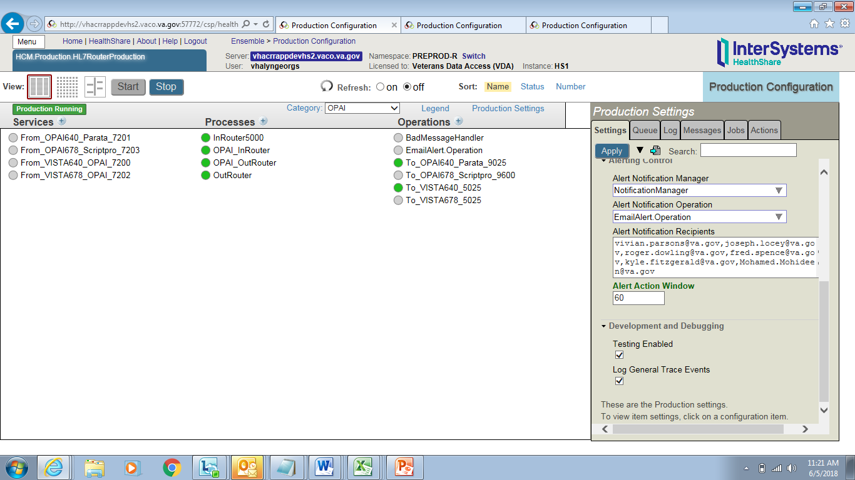

## Appendix C—Starting and Stopping a Health Connect Production

 **REF:** For details on what occurs when you start or stop a production, see the InterSystems book *Managing Ensemble Productions*.

### Starting Health Connect Production

To **start** a Health Connect Production, do the following:

1. Log in to the **Management Portal**.
2. Change to the appropriate namespace.
3. Go to the “Production List” page:

**Ensemble 🡪 List 🡪 Productions**

1. Find the **production** in the list and click it.
2. Click the **Open** button at the top of the list.
3. On the resulting “Production Configuration” page, click **Start** to display a dialog box.
4. In the dialog box, click **Open**. The system displays a new dialog box with the name of the **production**, its startup status, and any associated messages.

 **NOTE:** The system may also open Terminal windows. Do *not* close these windows. Click the **OK** button when it is displayed in the dialog box.

### Stopping Health Connect Production

To **stop** a Health Connect Production, do the following:

 **NOTE:** During this process ensure the Health Connect operation is **disabled**   
(see Appendix B, Step 2, “Configure connection details on Business Operations”).

1. Log in to the HealthShare **Management Portal** (Cache Cube).
2. Change to the appropriate namespace.
3. Go to the “Production List” page:

**Ensemble 🡪 List 🡪 Productions**

1. Find the **production** in the list and click it.
2. Click the **Open** button at the top of the list.
3. On the resulting “Production Configuration” page, click **Stop** to display a dialog box.
4. In the dialog box, click **OK**. The system displays a new dialog box with the following:

Name of the production.

Shutdown status.

Any associated messages.

 **NOTE:** The system may also open Terminal windows. Do *not* close these windows. Click the **OK** button when it is displayed in the dialog box.